

On World News Day (28 September), we need your support and your newsroom’s voice – now, more than ever.
Journalism is not just facts and data. It is about the human stories that connect us, the nuance that only people can capture, and the trust we can build together. In a world increasingly blurred by artificial intelligence and misinformation, your newsroom’s dedication to authentic, factual storytelling stands as a vital beacon.
Join 1,000+ newsrooms across the globe as we come together on World News Day to build understanding and defend our truth-tellers.
This is not just another campaign asking for your attention.
It is a unique endeavour that represents the unified voice of our industry, fighting on the frontlines for journalism’s irreplaceable role in society.
We urge you to use your editorial space, newsletters, social channels, and events to share this message and stand with us.
Together, we can strengthen the bond of trust with our audiences, counter misinformation, and prove that journalism, with its human insight and integrity, remains essential in today’s world.
Trusted media is of the essence. Choose Journalism. Choose Facts. Choose Truth.
More details of the campaign are below. To receive campaign news and materials, please sign up.

Get campaign materials, including print and digital ads, social media assets, op-eds, a cartoon and video, to help spread the World News Day message. Or, create your own campaign, using your newsletters, podcasts, social platforms and pages. Here is what is on offer from us:
1. Shared Campaign Assets
Materials are available via a Google folder from September 9. We will email you the links.
These include:
Animated Campaign Video: Trusted Media is of the Essence
- Format: MP4, YouTube embed link, Horizontal, Mobile
- Languages: English, Spanish, German, French, Portuguese, Arabic
- Preview: 1 September
- Don't see your language? Can you help with translations? Email us at worldnewsday@wan-ifra.org.
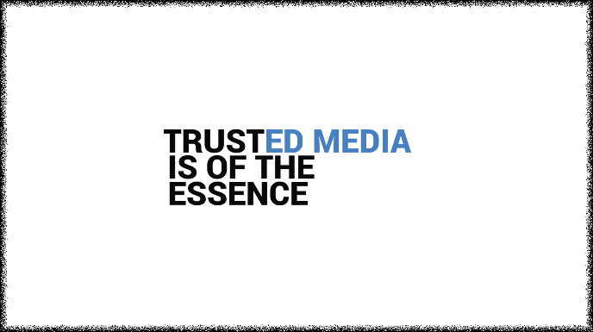

Social Media Content
- Elements: Pre-prepared posts, images, logos
- Languages: English, Spanish, German, French, Portuguese, Arabic
- Hashtags: #JournalismMatters #ChooseTruth #WorldNewsDay
Op-eds (more to come)
Op-eds will touch on news integrity in the age of AI; trust; the right to information; the danger in our midst, and the need to safeguard journalism. Contributors include:
- Project Kontinuum Founder Branko Brkic and Nobel Laureate Maria Ressa (English, Spanish)
- World Editors Forum President and Globe and Mail Editor in Chief, David Walmsley (English) with UNESCO (English, Spanish, French, Portuguese, Arabic)
- Agence France-Presse Global News Director Phil Chetwynd (English, French)
- EBU Head of News Liz Corbin and WAN-IFRA CEO Vincent Peyrègne (English, French, Spanish, Polish, German, Portuguese)
- Fernando Belzunce, author and Editor in Chief, Vocento (English, Spanish)
- Public Interest News Foundation's Jonathan Heawood (English)
- High-level panel on Public Interest Media (English, Spanish, French, Portuguese)
- Don't see your language? Can you help with additional translations? Email us at worldnewsday@wan-ifra.org
Cartoon
- An editorial offering from world-renowned cartoonist Zapiro (English)
Print Ad 1: THE LINE
- Formats: A4 dimensions, 400dpi. Downloadable as a PDF. Need a specific spec? Email us at worldnewsday@wan-ifra.org.
- Languages: English, French, German, Portuguese, Portuguese (Brazil), Spanish
- Words: The line separating truth from disinformation is under attack. On this World News Day, we, the news media, reaffirm our commitment to defend this border. To report. To investigate. To analyse, explain and expose. To provide clarity and insight, especially in unstable times. A trusted newsroom is more than a source of news. It is a civic partnership, a watchdog, a mirror. As Artificial Intelligence scrambles our sense of what’s real, we hold the line - because journalism has never mattered more. We are still guided by our foundational ideals with rigour, clarity, and resolve. We are here to represent you, the audience, and use facts and discovery to improve lives. This world is worth fighting for. TRUSTED MEDIA IS OF THE ESSENCE. Choose Journalism. Choose Facts. Choose Truth.
- Space for your logo: On request, your logo can be added to the bottom left.
- Don't see your language? Can you help with translations? Email us at worldnewsday@wan-ifra.org.
- Preview
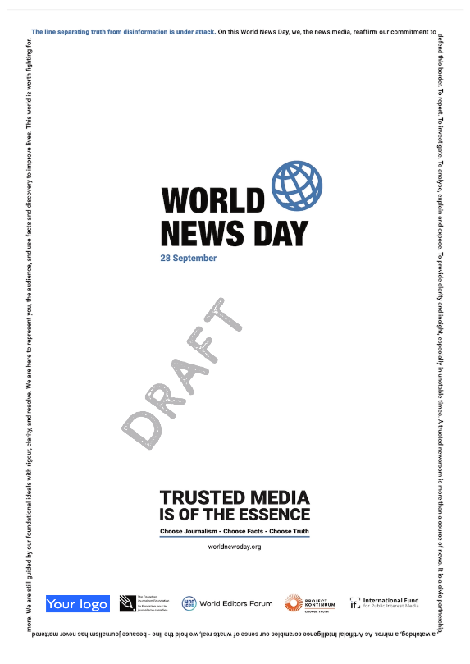
Print Ad 2: CLASSIC
- Formats: A4 dimensions, 400dpi. Downloadable as a PDF. Need a specific spec? Email us at worldnewsday@wan-ifra.org.
- Languages: English, French, German, Portuguese, Spanish
- Don't see your language? Can you help with translations? Email us at worldnewsday@wan-ifra.org.
- Words:
This World News Day, we, the news media, reaffirm our commitment to you: To report. To investigate. To analyse, explain, expose. To provide clarity and insight, especially in unstable times. A trusted newsroom is more than a source of news. It is a civic partner, a watchdog, a mirror.
As artificial intelligence scrambles our sense of what is real, we hold the line. Journalism has never mattered more.
TRUSTED MEDIA IS OF THE ESSENCE.
Our foundational ideals guide us with rigour, clarity, and resolve.
We are here to represent you, the audience, and use facts and discovery to improve lives. This world is worth fighting for.
Choose Journalism. Choose Facts. Choose Truth.
Read • Watch • Listen • Subscribe • Donate
Preview
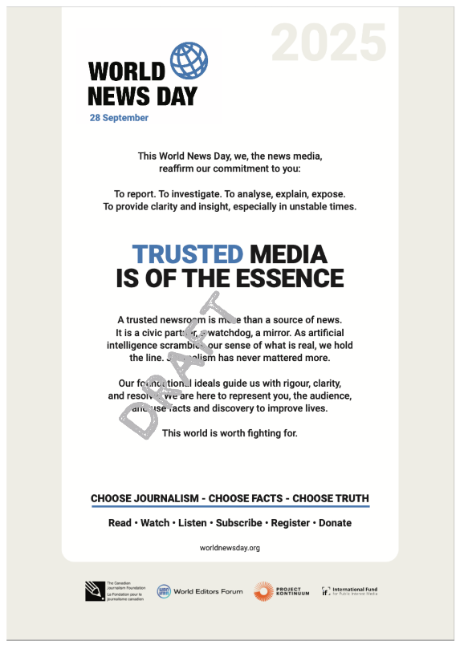
Digital Ads and Social Media
- Formats: Long Banner 1500x400, Medium rectangle 300x250, vertical rectangle 400x200. Downloadable as PNGs. Social: 1080x1080, 1080x1035, 16:9; Downloadable as PNGs
- Languages: English, Spanish, French, German, Portuguese, Portuguese (Brazil), Spanish
- Additional Translations are possible. Request at worldnewsday@wan-ifra.org
- Preview:
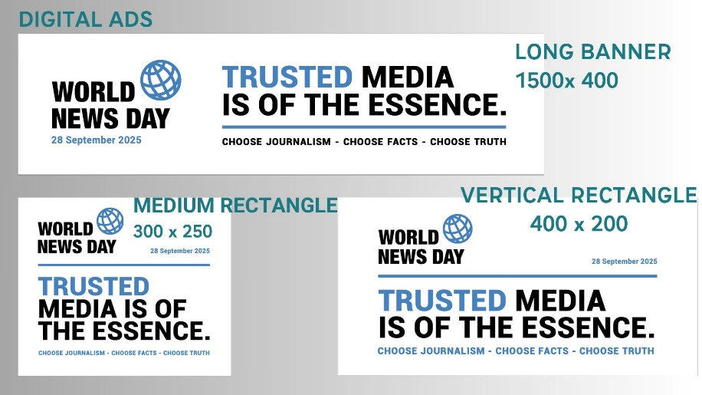
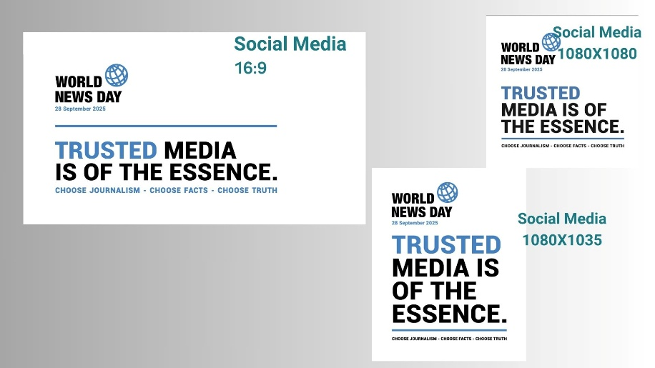
Logos
- Formats: Rectangle. Downloadable as PNGs
- Languages: Arabic, English, French, German, Indonesian, Portuguese, Spanish
- Additional Translations are possible. Request at worldnewsday@wan-ifra.org
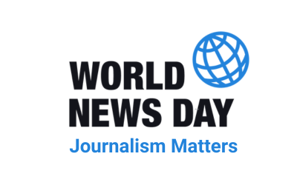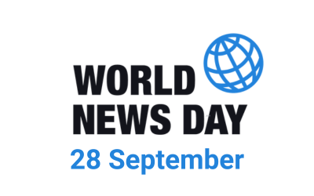
2. Own Content
Ideas to Promote the Campaign
- Create, commission and publish your own campaign materials. Advocate for your journalism using: Adverts, Articles, Commentary, Explainers, Interviews, Newsletters, Op-eds, Podcasts, Social Media Channels, Videos.
- Re-share your best journalism from your archives to show how it changed lives
- Introduce your journalists to your, and our, audiences: show the people behind the news and the backstory of your reporting.
- Invite readers into your newsroom. Let them meet your team and discover how the news process works.
- Host an event, in person or online to discuss the challenges and solutions.
- Collaborate with schools, universities, and libraries to underline the importance of fact-based journalism.

3. Logos
We will endeavour to publish all logos of news brands supporting the campaign on the World News Day website. If you have not already done so, please send your logo to worldnewsday@wan-ifra.org.
Need further help? Please contact Cherilyn Ireton via email at worldnewsday@wan-ifra.org.

PRESENTED BY

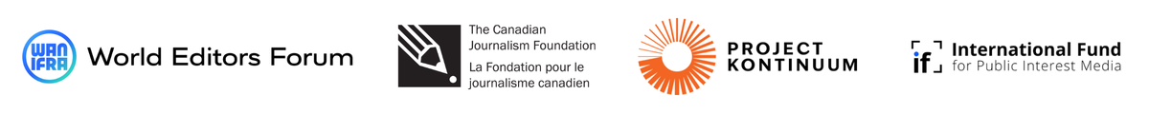

WAN-IFRA
World Association of News Publishers
Pariser Str. 1
60486 Frankfurt, Germany
Phone: +49.69.240063-0
Fax: +49.69.240063-300
CEO: Vincent Peyrègne
CH-170.6.000.007-8
170.6.000.007-8
HR des Kantons Zug
info@wan-ifra.org
www.wan-ifra.org

